Question 1Skipped
Which of the statements are incorrect when choosing between lakehouse and Datawarehouse?
Lakehouse can have special indexes and caching which are optimized for Machine learning
Correct answer
Lakehouse cannot serve low query latency with high reliability for BI workloads, only suitable for batch workloads.
Lakehouse can be accessed through various API’s including but not limited to Python/R/SQL
Traditional Data warehouses have storage and compute are coupled.
Lakehouse uses standard data formats like Parquet.
Overall explanation
The answer is Lakehouse cannot serve low query latency with high reliability for BI workloads, only suitable for batch workloads.

Lakehouse can replace traditional warehouses by leveraging storage and compute optimizations like caching to serve them with low query latency with high reliability.

Focus on comparisons between Spark Cache vs Delta Cache.

https://docs.databricks.com/delta/optimizations/delta-cache.html

What Is a Lakehouse? - The Databricks Blog

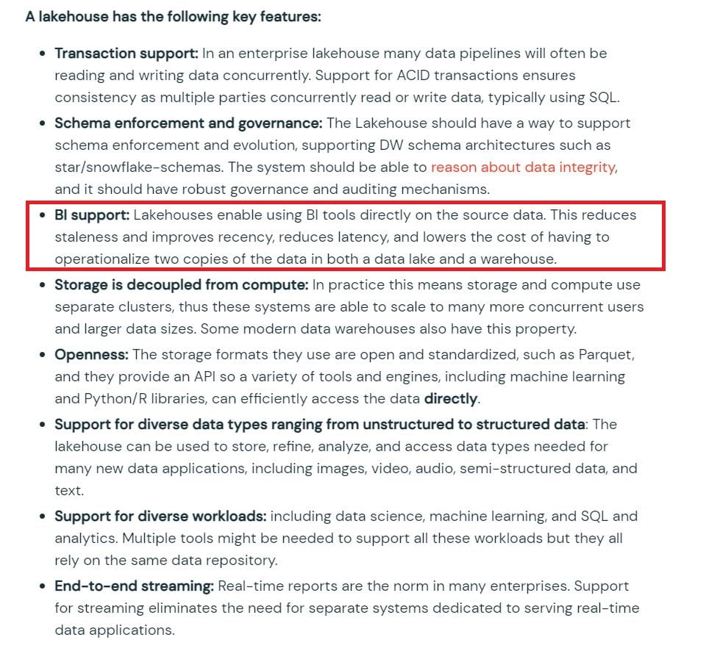
Domain
Databricks Lakehouse platform
Question 2Skipped
Which of the statements are correct about lakehouse?
Lakehouse only supports Machine learning workloads and Data warehouses support BI workloads
Lakehouse only supports end-to-end streaming workloads and Data warehouses support Batch workloads
Lakehouse does not support ACID
In Lakehouse Storage and compute are coupled
Correct answer
Lakehouse supports schema enforcement and evolution
Overall explanation
The answer is Lakehouse supports schema enforcement and evolution,

Lakehouse using Delta lake can not only enforce a schema on write which is contrary to traditional big data systems that can only enforce a schema on read, it also supports evolving schema over time with the ability to control the evolution.
For example below is the Dataframe writer API and it supports three modes of enforcement and evolution,

Default: Only enforcement, no changes are allowed and any schema drift/evolution will result in failure.

Merge: Flexible, supports enforcement and evolution

- New columns are added
- Evolves nested columns
- Supports evolving data types, like Byte to Short to Integer to Bigint
How to enable:
- DF.write.format("delta").option("mergeSchema", "true").saveAsTable("table_name")
- or
- spark.databricks.delta.schema.autoMerge = True ## Spark session

Overwrite: No enforcement
- Dropping columns
- Change string to integer
- Rename columns
How to enable:
- DF.write.format("delta").option("overwriteSchema", "True").saveAsTable("table_name")

What Is a Lakehouse? - The Databricks Blog

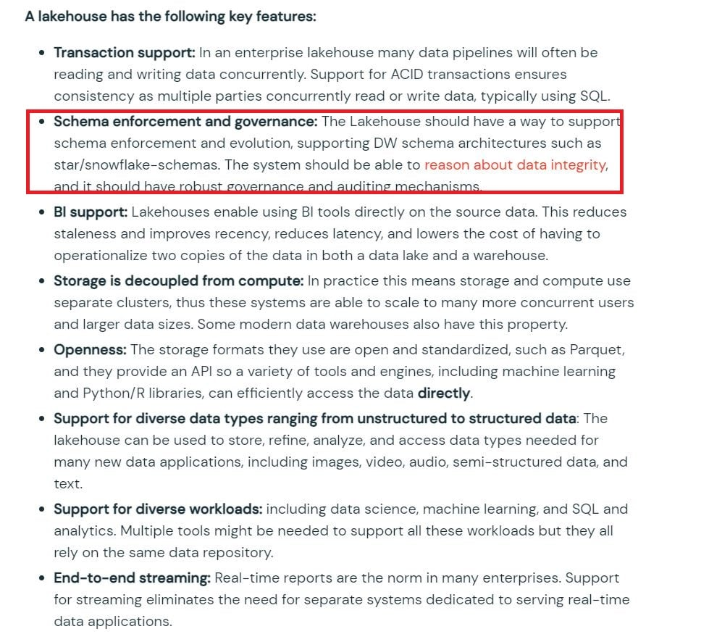

Domain
Databricks Lakehouse platform
Question 3Skipped
Which of the following are stored in the control pane of Databricks Architecture?
Job Clusters
All Purpose Clusters
Databricks Filesystem
Correct answer
Databricks Web Application
Delta tables
Overall explanation
The answer is Databricks Web Application

Azure Databricks architecture overview - Azure Databricks | Microsoft Docs

Databricks operates most of its services out of a control plane and a data plane, please note serverless features like SQL Endpoint and DLT compute use shared compute in Control pane.

Control Plane: Stored in Databricks Cloud Account

- The control plane includes the backend services that Databricks manages in its own Azure account. Notebook commands and many other workspace configurations are stored in the control plane and encrypted at rest.
Data Plane: Stored in Customer Cloud Account

- The data plane is managed by your Azure account and is where your data resides. This is also where data is processed. You can use Azure Databricks connectors so that your clusters can connect to external data sources outside of your Azure account to ingest data or for storage.

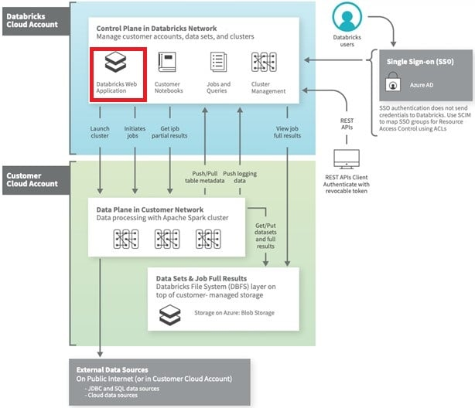
Domain
Databricks Lakehouse platform
Question 4Skipped
You have written a notebook to generate a summary data set for reporting, Notebook was scheduled using the job cluster, but you realized it takes 8 minutes to start the cluster, what feature can be used to start the cluster in a timely fashion so your job can run immediatley?
Setup an additional job to run ahead of the actual job so the cluster is running second job starts
Correct answer
Use the Databricks cluster pools feature to reduce the startup time
Use Databricks Premium edition instead of Databricks standard edition
Pin the cluster in the cluster UI page so it is always available to the jobs
Disable auto termination so the cluster is always running
Overall explanation
Cluster pools allow us to reserve VM's ahead of time, when a new job cluster is created VM are grabbed from the pool. Note: when the VM's are waiting to be used by the cluster only cost incurred is Azure. Databricks run time cost is only billed once VM is allocated to a cluster.
Here is a demo of how to setup a pool and follow some best practices,

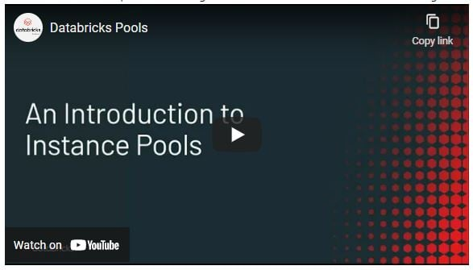

Domain
Databricks Lakehouse platform
Question 5Skipped
Which of the following developer operations in the CI/CD can only be implemented through a GIT provider when using Databricks Repos.
Trigger Databricks Repos pull API to update the latest version
Commit and push code
Create and edit code
Create a new branch
Correct answer
Pull request and review process
Overall explanation
The answer is Pull request and review process, please note: the question is asking for steps that are being implemented in GIT provider not Databricks Repos.

See below diagram to understand the role of Databricks Repos and Git provider plays when building a CI/CD workdlow.
All the steps highlighted in yellow can be done Databricks Repo, all the steps highlighted in Gray are done in a git provider like Github or Azure Devops.

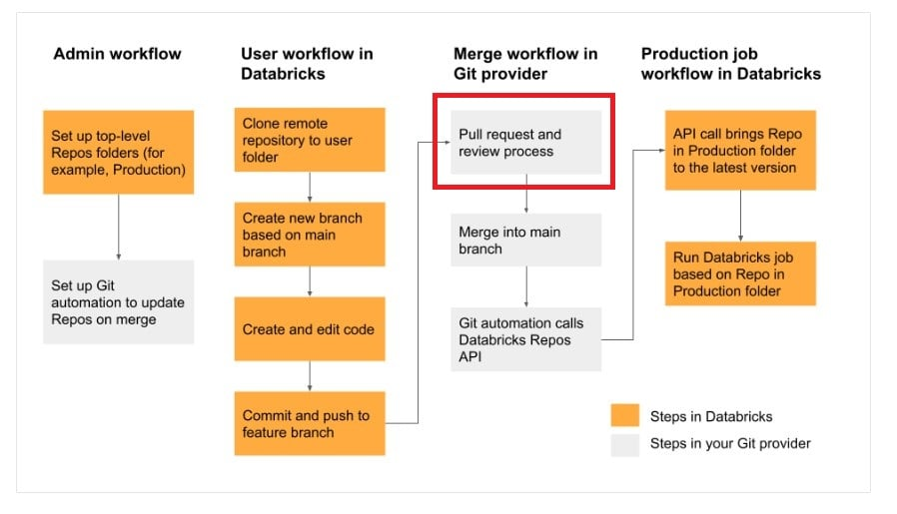

Domain
Databricks Lakehouse platform
Question 6Skipped
You have noticed the Data scientist team is using the notebook versioning feature with git integration, you have recommended them to switch to using Databricks Repos, which of the below reasons could be the reason the why the team needs to switch to Databricks Repos.
Databricks Repos allows multiple users to make changes
Databricks Repos allows merge and conflict resolution
Databricks Repos has a built-in version control system
Databricks Repos automatically saves changes
Correct answer
Databricks Repos allow you to add comments and select the changes you want to commit.
Overall explanation
The answer is Databricks Repos allow you to add comments and select the changes you want to commit.

Domain
Databricks Lakehouse platform
Question 7Skipped
Data science team members are using a single cluster to perform data analysis, although cluster size was chosen to handle multiple users and auto-scaling was enabled, the team realized queries are still running slow, what would be the suggested fix for this?

Setup multiple clusters so each team member has their own cluster
Disable the auto-scaling feature
Correct answer
Use High concurrency mode instead of the standard mode
Increase the size of the driver node
Overall explanation
The answer is Use High concurrency mode instead of the standard mode,

https://docs.databricks.com/clusters/cluster-config-best-practices.html#cluster-mode

High Concurrency clusters are ideal for groups of users who need to share resources or run ad-hoc jobs. Databricks recommends enabling autoscaling for High Concurrency clusters.

Domain
Databricks Lakehouse platform
Question 8Skipped
Which of the following SQL commands are used to append rows to an existing delta table?
APPEND INTO DELTA table_name
APPEND INTO table_name
COPY DELTA INTO table_name
Correct answer
INSERT INTO table_name
UPDATE table_name
Overall explanation
The answer is INSERT INTO table_name

Insert adds rows to an existing table, this is very similar to add rows a traditional Database or Datawarehouse.

Domain
Databricks Lakehouse platform
Question 9Skipped
How are Delt tables stored?
Correct answer
A Directory where parquet data files are stored, a sub directory _delta_log where meta data, and the transaction log is stored as JSON files.
A Directory where parquet data files are stored, all of the meta data is stored in memory
A Directory where parquet data files are stored in Data plane, a sub directory _delta_log where meta data, history and log is stored in control pane.
A Directory where parquet data files are stored, all of the metadata is stored in parquet files
Data is stored in Data plane and Metadata and delta log are stored in control pane
Overall explanation
The answer is A Directory where parquet data files are stored, a sub directory _delta_log where meta data, and the transaction log is stored as JSON files.

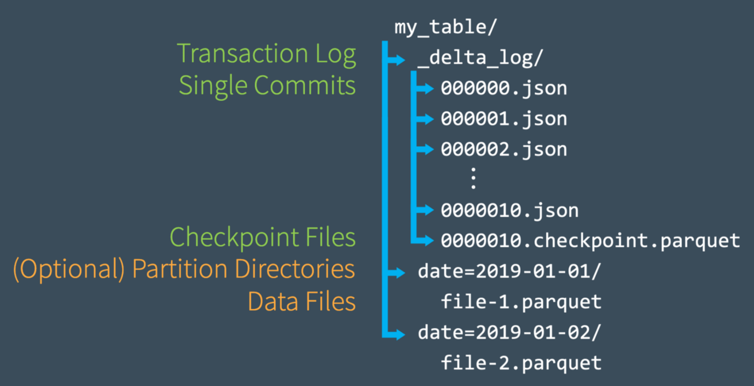
Domain
Databricks Lakehouse platform
Question 10Skipped
While investigating a data issue in a Delta table, you wanted to review logs to see when and who updated the table, what is the best way to review this data?
Review event logs in the Workspace
Run SQL SHOW HISTORY table_name
Check Databricks SQL Audit logs
Correct answer
Run SQL command DESCRIBE HISTORY table_name
Review workspace audit logs
Overall explanation
The answer is Run SQL command DESCRIBE HISTORY table_name.

here is the sample data of how DESCRIBE HISTORY table_name looks

- +-------+-------------------+------+--------+---------+--------------------+----+--------+---------+-----------+--------------+-------------+--------------------+
- |version| timestamp|userId|userName|operation| operationParameters| job|notebook|clusterId|readVersion|isolationLevel|isBlindAppend| operationMetrics|
- +-------+-------------------+------+--------+---------+--------------------+----+--------+---------+-----------+--------------+-------------+--------------------+
- | 5|2019-07-29 14:07:47| null| null| DELETE|[predicate -> ["(...|null| null| null| 4| Serializable| false|[numTotalRows -> ...|
- | 4|2019-07-29 14:07:41| null| null| UPDATE|[predicate -> (id...|null| null| null| 3| Serializable| false|[numTotalRows -> ...|
- | 3|2019-07-29 14:07:29| null| null| DELETE|[predicate -> ["(...|null| null| null| 2| Serializable| false|[numTotalRows -> ...|
- | 2|2019-07-29 14:06:56| null| null| UPDATE|[predicate -> (id...|null| null| null| 1| Serializable| false|[numTotalRows -> ...|
- | 1|2019-07-29 14:04:31| null| null| DELETE|[predicate -> ["(...|null| null| null| 0| Serializable| false|[numTotalRows -> ...|
- | 0|2019-07-29 14:01:40| null| null| WRITE|[mode -> ErrorIfE...|null| null| null| null| Serializable| true|[numFiles -> 2, n...|
- +-------+-------------------+------+--------+---------+--------------------+----+--------+---------+-----------+--------------+-------------+--------------------+
Domain
Databricks Lakehouse platform
Question 11Skipped
While investigating a performance issue, you realized that you have too many small files for a given table, which command are you going to run to fix this issue
COMPACT table_name
VACUUM table_name
MERGE table_name
SHRINK table_name
Correct answer
OPTIMIZE table_name
Overall explanation
The answer is OPTIMIZE table_name,

Optimize compacts small parquet files into a bigger file, by default the size of the files are determined based on the table size at the time of OPTIMIZE, the file size can also be set manually or adjusted based on the workload.

https://docs.databricks.com/delta/optimizations/file-mgmt.html

Tune file size based on Table size

To minimize the need for manual tuning, Databricks automatically tunes the file size of Delta tables based on the size of the table. Databricks will use smaller file sizes for smaller tables and larger file sizes for larger tables so that the number of files in the table does not grow too large.

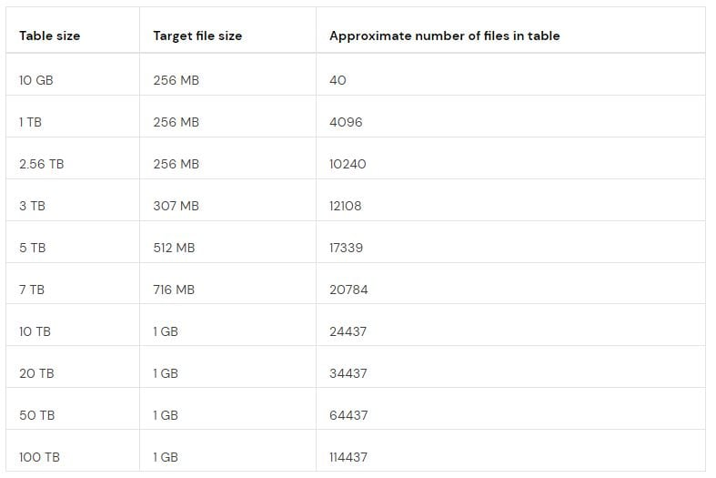
Domain
Databricks Lakehouse platform
Question 12Skipped
Create a sales database using the DBFS location 'dbfs:/mnt/delta/databases/sales.db/'
CREATE DATABASE sales FORMAT DELTA LOCATION 'dbfs:/mnt/delta/databases/sales.db/'’
CREATE DATABASE sales USING LOCATION 'dbfs:/mnt/delta/databases/sales.db/'
Correct answer
CREATE DATABASE sales LOCATION 'dbfs:/mnt/delta/databases/sales.db/'
The sales database can only be created in Delta lake
CREATE DELTA DATABASE sales LOCATION 'dbfs:/mnt/delta/databases/sales.db/'
Overall explanation
The answer is
CREATE DATABASE sales LOCATION 'dbfs:/mnt/delta/databases/sales.db/'

Note: with the introduction of the Unity catalog and three-layer namespace usage of SCHEMA and DATABASE is interchangeable
Domain
ELT with Spark SQL and Python
Question 13Skipped
What is the type of table created when you issue SQL DDL command CREATE TABLE sales (id int, units int)
Query fails due to missing location
Query fails due to missing format
Correct answer
Managed Delta table
External Table
Managed Parquet table
Overall explanation
Answer is Managed Delta table
Anytime a table is created without the Location keyword it is considered a managed table, by default all managed tables DELTA tables
Syntax
CREATE TABLE table_name ( column column_data_type…)
Domain
ELT with Spark SQL and Python
Question 14Skipped
How to determine if a table is a managed table vs external table?
Run IS_MANAGED(‘table_name’) function
All external tables are stored in data lake, managed tables are stored in DELTA lake
All managed tables are stored in unity catalog
Correct answer
Run SQL command DESCRIBE EXTENDED table_name and check type
A. Run SQL command SHOW TABLES to see the type of the table
Overall explanation
The answer is Run SQL command DESCRIBE EXTENDED table_name and check type

Example of External table
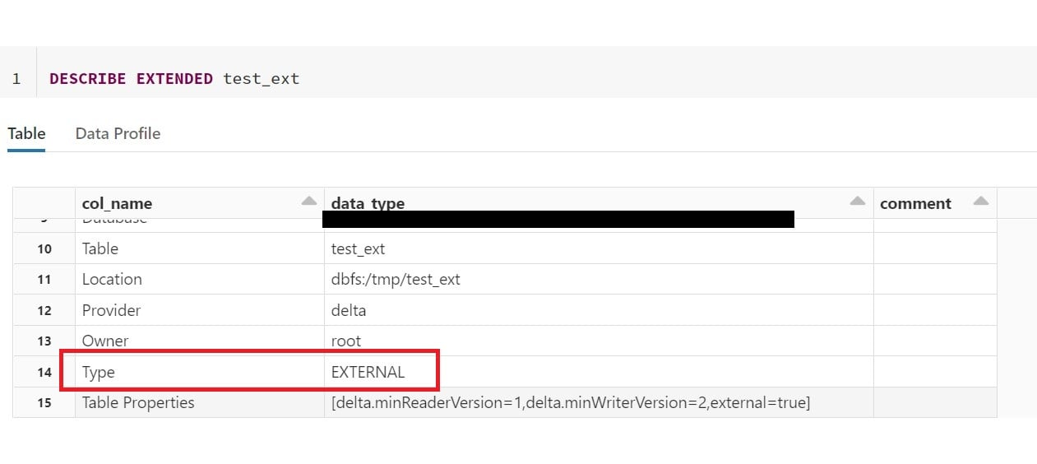
Example of managed table

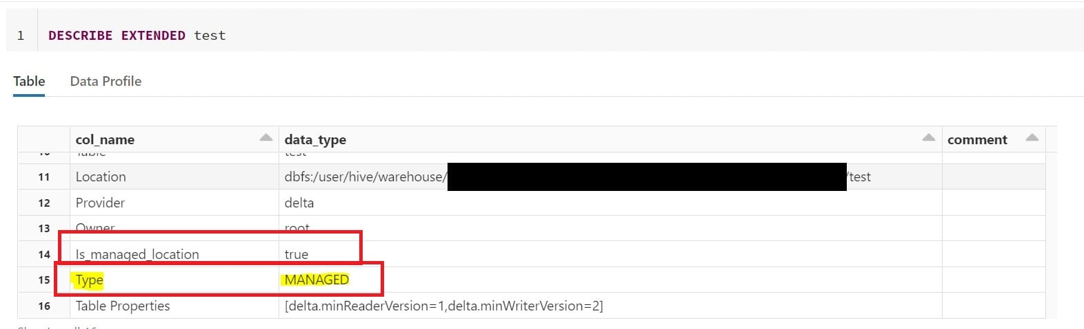
Domain
ELT with Spark SQL and Python
Question 15Skipped
Which of the below SQL commands creates a session scoped temporary view?
Correct answer
- CREATE OR REPLACE TEMPORARY VIEW view_name
- AS SELECT * FROM table_name
- CREATE OR REPLACE LOCAL TEMPORARY VIEW view_name
- AS SELECT * FROM table_name
- CREATE OR REPLACE GLOBAL TEMPORARY VIEW view_name
- AS SELECT * FROM table_name
- CREATE OR REPLACE VIEW view_name
- AS SELECT * FROM table_name
- CREATE OR REPLACE LOCAL VIEW view_name
- AS SELECT * FROM table_name
Overall explanation
The answer is
- CREATE OR REPLACE TEMPORARY VIEW view_name
- AS SELECT * FROM table_name
The default temporary view is session scoped, as soon as the session ends or if a notebook is detached session scoped temporary view is dropped.
Domain
ELT with Spark SQL and Python
Question 16Skipped
Drop the customers database and associated tables and data, all of the tables inside the database are managed tables. Which of the following SQL commands will help you accomplish this?
DROP DATABASE customers FORCE
Correct answer
DROP DATABASE customers CASCADE
DROP DATABASE customers INCLUDE
All the tables must be dropped first before dropping database
DROP DELTA DATABSE customers
Overall explanation
The answer is DROP DATABASE customers CASCADE
Drop database with cascade option drops all the tables, since all of the tables inside the database are managed tables we do not need to perform any additional steps to clean the data in the storage.
Domain
ELT with Spark SQL and Python
Question 17Skipped
Define an external SQL table by connecting to a local instance of an SQLite database using JDBC
- CREATE TABLE users_jdbc
- USING SQLITE
- OPTIONS (
- url = "jdbc:/sqmple_db",
- dbtable = "users"
- )
- CREATE TABLE users_jdbc
- USING SQL
- URL = {server:"jdbc:/sqmple_db",dbtable: “users”}
- CREATE TABLE users_jdbc
- USING SQL
- OPTIONS (
- url = "jdbc:sqlite:/sqmple_db",
- dbtable = "users"
- )
- CREATE TABLE users_jdbc
- USING org.apache.spark.sql.jdbc.sqlite
- OPTIONS (
- url = "jdbc:/sqmple_db",
- dbtable = "users"
- )
Correct answer
- CREATE TABLE users_jdbc
- USING org.apache.spark.sql.jdbc
- OPTIONS (
- url = "jdbc:sqlite:/sqmple_db",
- dbtable = "users"
- )
Overall explanation
The answer is,

- CREATE TABLE users_jdbc
- USING org.apache.spark.sql.jdbc
- OPTIONS (
- url = "jdbc:sqlite:/sqmple_db",
- dbtable = "users"
- )

Databricks runtime currently supports connecting to a few flavors of SQL Database including SQL Server, My SQL, SQL Lite and Snowflake using JDBC.

- CREATE TABLE <jdbcTable>
- USING org.apache.spark.sql.jdbc or JDBC
- OPTIONS (
- url = "jdbc:<databaseServerType>://<jdbcHostname>:<jdbcPort>",
- dbtable " = <jdbcDatabase>.atable",
- user = "<jdbcUsername>",
- password = "<jdbcPassword>"
- )

For more detailed documentation
SQL databases using JDBC - Azure Databricks | Microsoft Docs

Domain
ELT with Spark SQL and Python
Question 18Skipped
When defining external tables using formats CSV, JSON, TEXT, BINARY any query on the external tables caches the data and location for performance reasons, so within a given spark session any new files that may have arrived will not be available after the initial query. How can we address this limitation?
UNCACHE TABLE table_name
CACHE TABLE table_name
Correct answer
REFRESH TABLE table_name
BROADCAST TABLE table_name
CLEAR CACH table_name
Overall explanation
The answer is REFRESH TABLE table_name
REFRESH TABLE table_name will force Spark to refresh the availability of external files and any changes.
When spark queries an external table it caches the files associated with it, so that way if the table is queried again it can use the cached files so it does not have to retrieve them again from cloud object storage, but the drawback here is that if new files are available Spark does not know until the Refresh command is ran.
Domain
ELT with Spark SQL and Python
Question 19Skipped
Which of the following table constraints that can be enforced on Delta lake tables are supported?
Primary key, foreign key, Not Null, Check Constraints
Primary key, Not Null, Check Constraints
Default, Not Null, Check Constraints
Correct answer
Not Null, Check Constraints
Unique, Not Null, Check Constraints
Overall explanation
The answer is Not Null, Check Constraints
https://docs.microsoft.com/en-us/azure/databricks/delta/delta-constraints

- CREATE TABLE events( id LONG,
- date STRING,
- location STRING,
- description STRING
- ) USING DELTA;
ALTER TABLE events CHANGE COLUMN id SET NOT NULL;
ALTER TABLE events ADD CONSTRAINT dateWithinRange CHECK (date > '1900-01-01');

Note: Databricks as of DBR 11.1 added support for Primary Key and Foreign Key when Unity Catalog is enabled but this is for information purposes only these are not actually enforced. You may ask then why are we defining these if they are not enforced, so especially these information constraints are very helpful if you have a BI tool that can benefit from knowing the relationship between the tables, so it will be easy when creating reports/dashboards or understanding the data model when using any Data modeling tool.
Primary and Foreign Key

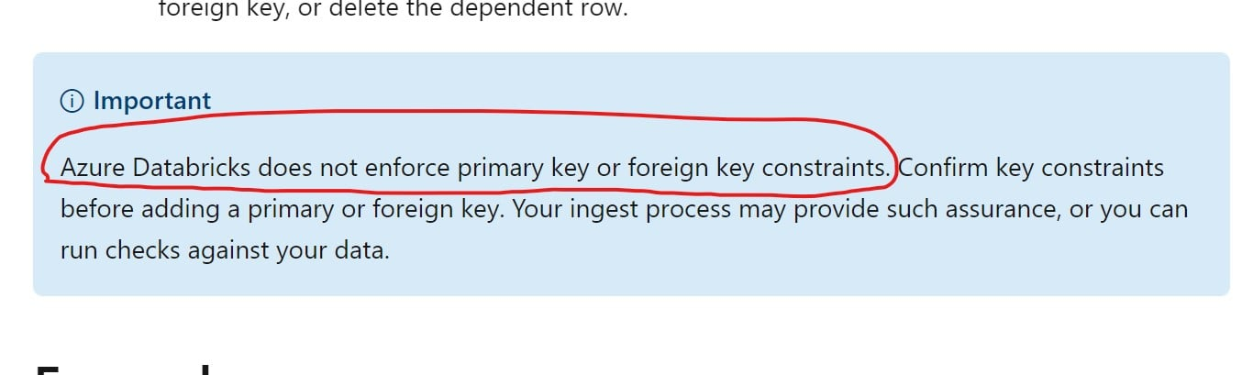

Domain
ELT with Spark SQL and Python
Question 20Skipped
The data engineering team is looking to add a new column to the table, but the QA team would like to test the change before implementing in production, which of the below options allow you to quickly copy the table from Prod to the QA environment, modify and run the tests?
DEEP CLONE
SHADOW CLONE
ZERO COPY CLONE
Correct answer
SHALLOW CLONE
METADATA CLONE
Overall explanation
The answer is SHALLOW CLONE

SHALLOW CLONE If you wish to create a copy of a table quickly to test out applying changes without the risk of modifying the current table, SHALLOW CLONE can be a good option. Shallow clones just copy the Delta transaction logs, meaning that the data doesn't move so it can be very quick.

- CREATE OR REPLACE TABLE {new_table_name} SHALLOW CLONE {source_table_name}|[LOCATION path]

DEEP CLONE fully copies data and metadata from a source table to a target. This copy occurs incrementally, so executing this command again can sync changes from the source to the target location. It copies all of the data and transaction logs this can take a long time based on the size of the table.

- CREATE OR REPLACE TABLE {new_table_name} DEEP CLONE {source_table_name}|[LOCATION path]
Domain
ELT with Spark SQL and Python
Question 21Skipped
Sales team is looking to get a report on a measure number of units sold by date, below is the schema. Fill in the blank with the appropriate array function.

Table orders: orderDate DATE, orderIds ARRAY<INT>

Table orderDetail: orderId INT, unitsSold INT, salesAmt DOUBLE

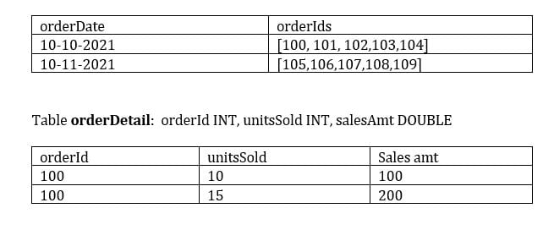

- SELECT orderDate, SUM(unitsSold)
- FROM orderDetail od
- JOIN (select orderDate, ___________(orderIds) as orderId FROM orders) o
- ON o.orderId = od.orderId
- GROUP BY orderDate

FLATTEN
EXTEND
Correct answer
EXPLODE
EXTRACT
ARRAY_FLATTEN
Overall explanation
The answer is EXPLODE,

explode is table-valued function, takes an array or map and returns a row for each element in the array.

For below table
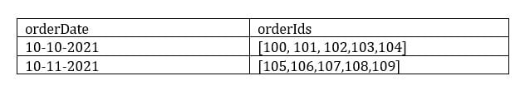

select explode(orderIds) orderId, orderdate from orders

This above would return a result something like below, creates a row for each element in the array

OrderDate orderId
10-10-2021 100
10-10-2021 101
10-10-2021 102
...
..
Domain
ELT with Spark SQL and Python
Question 22Skipped
You are asked to write a python function that can read data from a delta table and return the DataFrame, which of the following is correct?
Python function cannot return a DataFrame
Write SQL UDF to return a DataFrame
Write SQL UDF that can return tabular data
Python function will result in out of memory error due to data volume
Correct answer
Python function can return a DataFrame
Overall explanation
The answer is Python function can return a DataFrame

The function would something like this,

- get_source_dataframe(tablename):
- df = spark.read.table(tablename)
- return df

df = get_source_dataframe('test_table')
since there is no action spark returns a Dataframe and assigns to df python variable

Domain
ELT with Spark SQL and Python
Question 23Skipped
What is the output of the below function when executed with input parameters 1, 3 :

- def check_input(x,y):
- if x < y:
- x= x+1
- if x<y:
- x= x+1
- if x <y:
- x = x+1
- return x

check_input(1,3)
1
2
Correct answer
3
4
5
Overall explanation
The answer is 3
Domain
ELT with Spark SQL and Python
Question 24Skipped
Which of the following SQL statements can replace a python variable, when the notebook is set in SQL mode

- table_name = "sales"
- schema_name = "bronze"
spark.sql(f"SELECT * FROM f{schema_name.table_name}")
spark.sql(f"SELECT * FROM {schem_name.table_name}")
spark.sql(f"SELECT * FROM ${schema_name}.${table_name}")
Correct answer
spark.sql(f"SELECT * FROM {schema_name}.{table_name}")
spark.sql("SELECT * FROM schema_name.table_name")
Overall explanation
The answer is spark.sql(f"SELECT * FROM {schema_name}.{table_name}")
Domain
ELT with Spark SQL and Python
Question 25Skipped
When writing streaming data, Spark’s structured stream supports the below write modes
Append, Delta, Complete
Delta, Complete, Continuous
Correct answer
Append, Complete, Update
Complete, Incremental, Update
Append, overwrite, Continuous
Overall explanation
The answer is Append, Complete, Update

- Append mode (default) - This is the default mode, where only the new rows added to the Result Table since the last trigger will be outputted to the sink. This is supported for only those queries where rows added to the Result Table is never going to change. Hence, this mode guarantees that each row will be output only once (assuming fault-tolerant sink). For example, queries with only select, where, map, flatMap, filter, join, etc. will support Append mode.
- Complete mode - The whole Result Table will be outputted to the sink after every trigger. This is supported for aggregation queries.
- Update mode - (Available since Spark 2.1.1) Only the rows in the Result Table that were updated since the last trigger will be outputted to the sink. More information to be added in future releases.

Domain
Incremental Data processing
Question 26Skipped
When using the complete mode to write stream data, how does it impact the target table?
Entire stream waits for complete data to write
Stream must complete to write the data
Target table cannot be updated while stream is pending
Correct answer
Target table is overwritten for each batch
Delta commits transaction once the stream is stopped
Overall explanation
The answer is Target table is overwritten for each batch

Complete mode - The whole Result Table will be outputted to the sink after every trigger. This is supported for aggregation queries
Domain
Incremental Data processing
Question 27Skipped
At the end of the inventory process a file gets uploaded to the cloud object storage, you are asked to build a process to ingest data which of the following method can be used to ingest the data incrementally, the schema of the file is expected to change overtime ingestion process should be able to handle these changes automatically. Below is the auto loader command to load the data, fill in the blanks for successful execution of the below code.

- spark.readStream
- .format("cloudfiles")
- .option("cloudfiles.format",”csv)
- .option("_______", ‘dbfs:/location/checkpoint/’)
- .load(data_source)
- .writeStream
- .option("_______",’ dbfs:/location/checkpoint/’)
- .option("mergeSchema", "true")
- .table(table_name))

checkpointlocation, schemalocation
checkpointlocation, cloudfiles.schemalocation
schemalocation, checkpointlocation
Correct answer
cloudfiles.schemalocation, checkpointlocation
cloudfiles.schemalocation, cloudfiles.checkpointlocation
Overall explanation
The answer is cloudfiles.schemalocation, checkpointlocation
When reading the data cloudfiles.schemalocation is used to store the inferred schema of the incoming data.
When writing a stream to recover from failures checkpointlocation is used to store the offset of the byte that was most recently processed.
Domain
Incremental Data processing
Question 28Skipped
When working with AUTO LOADER you noticed that most of the columns that were inferred as part of loading are string data types including columns that were supposed to be integers, how can we fix this?
Provide the schema of the source table in the cloudfiles.schemalocation
Provide the schema of the target table in the cloudfiles.schemalocation
Correct answer
Provide schema hints
Update the checkpoint location
Correct the incoming data by explicitly casting the data types
Overall explanation
The answer is, Provide schema hints.

- spark.readStream \
- .format("cloudFiles") \
- .option("cloudFiles.format", "csv") \
- .option("header", "true") \
- .option("cloudFiles.schemaLocation", schema_location) \
- .option("cloudFiles.schemaHints", "id int, description string")
- .load(raw_data_location)
- .writeStream \
- .option("checkpointLocation", checkpoint_location) \
- .start(target_delta_table_location)

.option("cloudFiles.schemaHints", "id int, description string")
# Here we are providing a hint that id column is int and the description is a string
When cloudfiles.schemalocation is used to store the output of the schema inference during the load process, with schema hints you can enforce data types for known columns ahead of time.

Domain
Incremental Data processing
Question 29Skipped
You have configured AUTO LOADER to process incoming IOT data from cloud object storage every 15 mins, recently a change was made to the notebook code to update the processing logic but the team later realized that the notebook was failing for the last 24 hours, what steps team needs to take to reprocess the data that was not loaded after the notebook was corrected?
Move the files that were not processed to another location and manually copy the files into the ingestion path to reprocess them
Enable back_fill = TRUE to reprocess the data
Delete the checkpoint folder and run the autoloader again
Correct answer
Autoloader automatically re-processes data that was not loaded
Manually re-load the data
Overall explanation
The answer is,
Autoloader automatically re-processes data that was not loaded using the checkpoint.
Domain
Incremental Data processing
Question 30Skipped
Which of the following Structured Streaming queries is performing a hop from a bronze table to a Silver table?
- (spark.table("sales").groupBy("store")
- .agg(sum("sales")).writeStream
- .option("checkpointLocation",checkpointPath)
- .outputMode("complete")
- .table("aggregatedSales"))
- (spark.table("sales").agg(sum("sales"),sum("units"))
- .writeStream
- .option("checkpointLocation",checkpointPath)
- .outputMode("complete")
- .table("aggregatedSales"))
Correct answer
- (spark.table("sales")
- .withColumn("avgPrice", col("sales") / col("units"))
- .writeStream
- .option("checkpointLocation", checkpointPath)
- .outputMode("append")
- .table("cleanedSales"))
- (spark.readStream.load(rawSalesLocation)
- .writeStream
- .option("checkpointLocation", checkpointPath)
- .outputMode("append")
- .table("uncleanedSales") )
- (spark.read.load(rawSalesLocation)
- .writeStream
- .option("checkpointLocation", checkpointPath)
- .outputMode("append")
- .table("uncleanedSales") )
Overall explanation
The question is asking to identify a structured streaming command that is moving data from bronze to silver.

The answer is
- (spark.table("sales")
- .withColumn("avgPrice", col("sales") / col("units"))
- .writeStream
- .option("checkpointLocation", checkpointPath)
- .outputMode("append")
- .table("cleanedSales"))
We are preserving the grain of incoming data and enriching the data by adding avg price, the other options listed use aggregations which are mostly performed on top of the silver to move data to Gold.

Exam focus: Please review the below image and understand the role of each layer(bronze, silver, gold) in medallion architecture, you will see varying questions targeting each layer and its purpose.

Sorry I had to add the watermark some people in Udemy are copying my content.
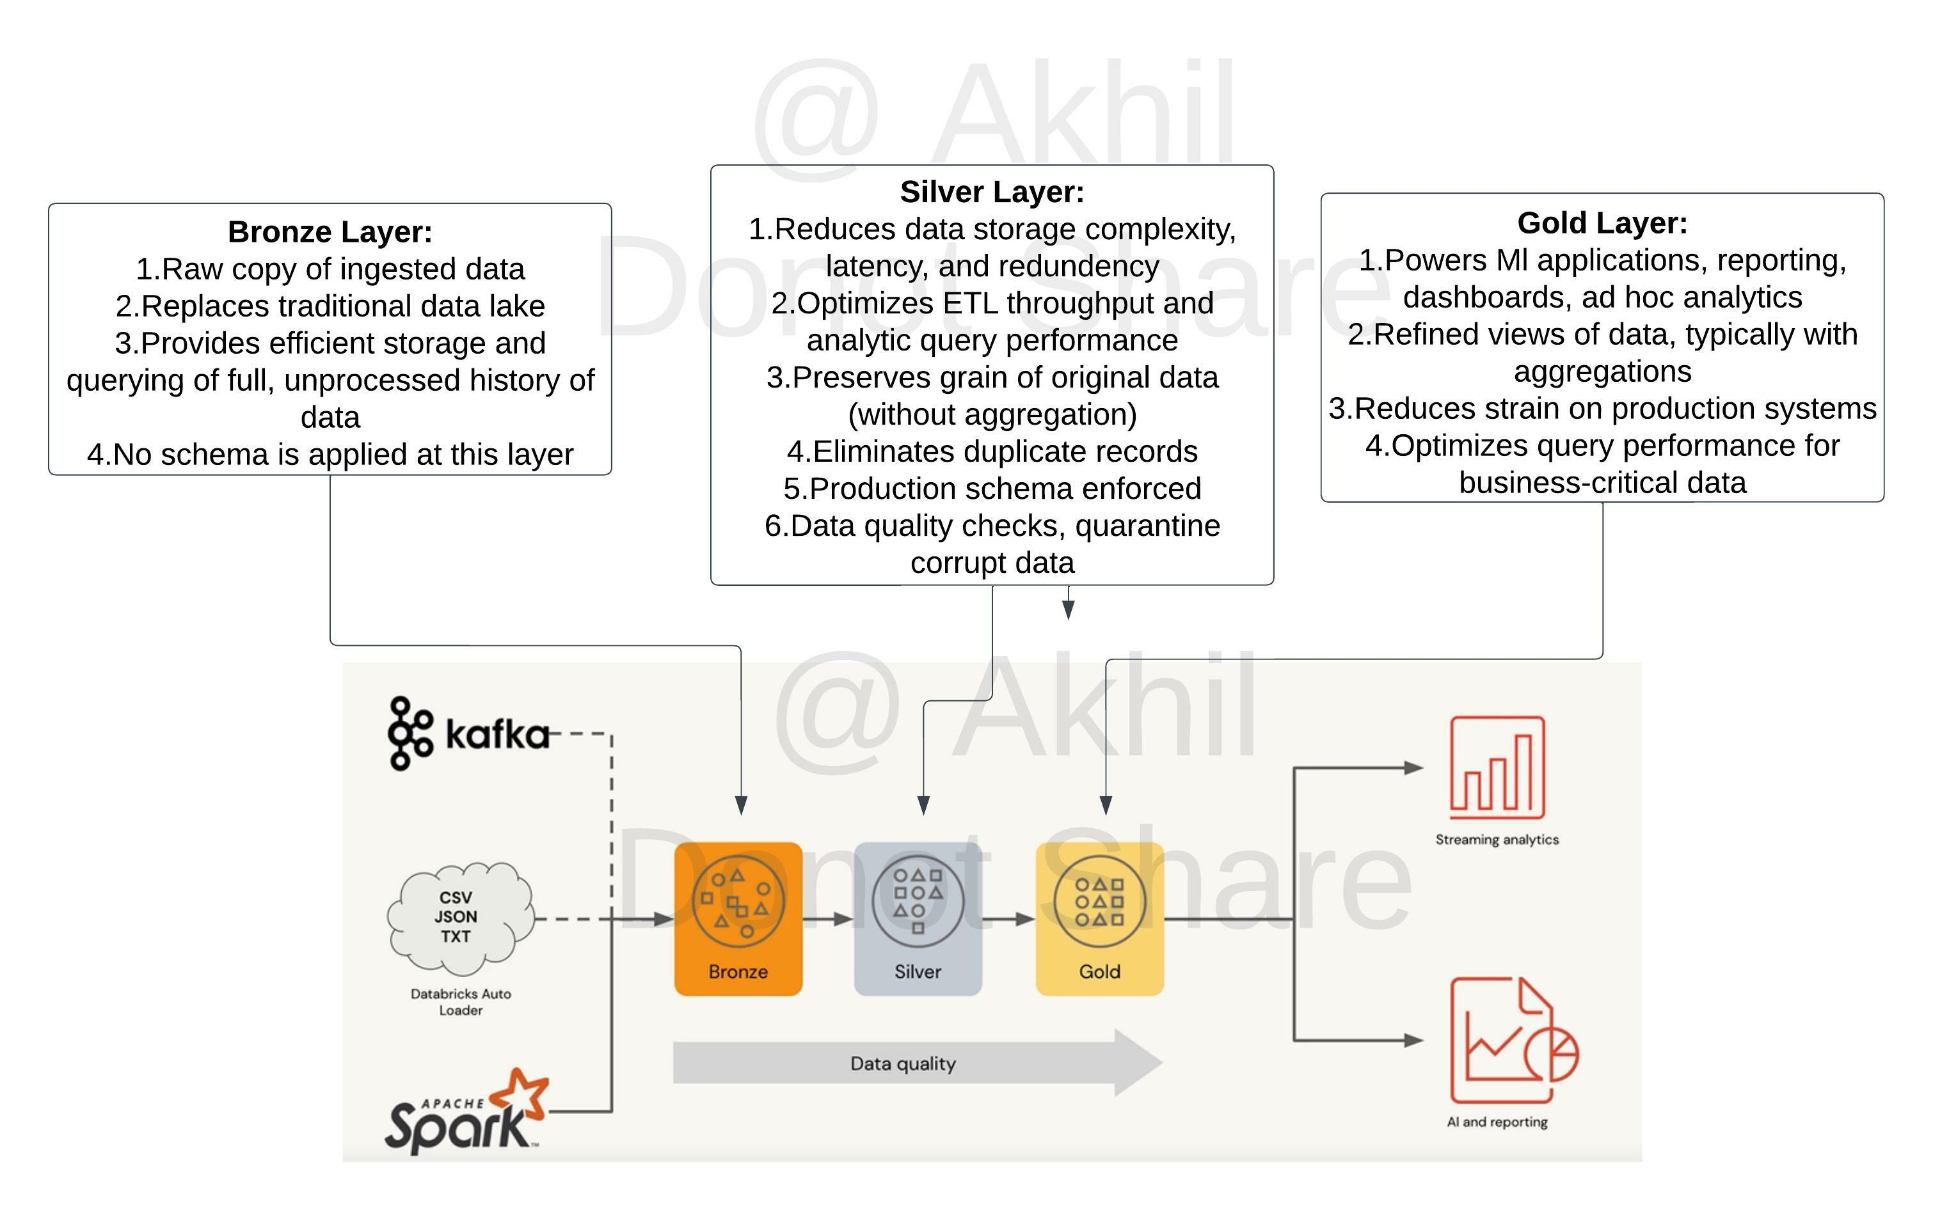

Domain
Incremental Data processing
Question 31Skipped
Which of the following Structured Streaming queries successfully performs a hop from a Silver to Gold table?
Correct answer
- (spark.table("sales")
- .groupBy("store")
- .agg(sum("sales"))
- .writeStream
- .option("checkpointLocation", checkpointPath)
- .outputMode("complete")
- .table("aggregatedSales") )
- (spark.table("sales")
- .writeStream
- .option("checkpointLocation", checkpointPath)
- .outputMode("complete")
- .table("sales") )
- (spark.table("sales")
- .withColumn("avgPrice", col("sales") / col("units"))
- .writeStream
- .option("checkpointLocation", checkpointPath)
- .outputMode("append")
- .table("cleanedSales") )
- (spark.readStream.load(rawSalesLocation)
- .writeStream
- .option("checkpointLocation", checkpointPath)
- .outputMode("append")
- .table("uncleanedSales") )
- (spark.read.load(rawSalesLocation)
- .writeStream
- .option("checkpointLocation", checkpointPath)
- .outputMode("append")
- .table("uncleanedSales") )
Overall explanation
The answer is
- (spark.table("sales")
- .groupBy("store")
- .agg(sum("sales"))
- .writeStream
- .option("checkpointLocation", checkpointPath)
- .outputMode("complete")
- .table("aggregatedSales") )

The gold layer is normally used to store aggregated data

Review the below link for more info,
Medallion Architecture – Databricks
Gold Layer:

1. Powers Ml applications, reporting, dashboards, ad hoc analytics
2. Refined views of data, typically with aggregations
3. Reduces strain on production systems
4. Optimizes query performance for business-critical data

Exam focus: Please review the below image and understand the role of each layer(bronze, silver, gold) in medallion architecture, you will see varying questions targeting each layer and its purpose.

Sorry I had to add the watermark some people in Udemy are copying my content.


Domain
Incremental Data processing
Question 32Skipped
Which of the following Auto loader structured streaming commands successfully performs a hop from the landing area into Bronze?
- spark\
- .readStream\
- .format("csv")\
- .option("cloudFiles.schemaLocation", checkpoint_directory)\
- .load("landing")\
- .writeStream.option("checkpointLocation", checkpoint_directory)\
- .table(raw)
Correct answer
- spark\
- .readStream\
- .format("cloudFiles")\
- .option("cloudFiles.format","csv")\
- .option("cloudFiles.schemaLocation", checkpoint_directory)\
- .load("landing")\
- .writeStream.option("checkpointLocation", checkpoint_directory)\
- .table(raw)
- spark\
- .read\
- .format("cloudFiles")\
- .option("cloudFiles.format",”csv”)\
- .option("cloudFiles.schemaLocation", checkpoint_directory)\
- .load("landing")\
- .writeStream.option("checkpointLocation", checkpoint_directory)\
- .table(raw)
- spark\
- .readStream\
- .load(rawSalesLocation)\
- .writeStream \
- .option("checkpointLocation", checkpointPath).outputMode("append")\
- .table("uncleanedSales")
- spark\
- .read\
- .load(rawSalesLocation) \
- .writeStream\
- .option("checkpointLocation", checkpointPath) \
- .outputMode("append")\
- .table("uncleanedSales")
Overall explanation
The answer is
- spark\
- .readStream\
- .format("cloudFiles") \# use Auto loader
- .option("cloudFiles.format","csv") \ # csv format files
- .option("cloudFiles.schemaLocation", checkpoint_directory)\
- .load('landing')\
- .writeStream.option("checkpointLocation", checkpoint_directory)\
- .table(raw)

Note: if you chose the below option which is incorrect because it does not have readStream
- spark.read.format("cloudFiles")
- .option("cloudFiles.format",”csv”)
- ...
- ..
- ..

Exam focus: Please review the below image and understand the role of each layer(bronze, silver, gold) in medallion architecture, you will see varying questions targeting each layer and its purpose.

Sorry I had to add the watermark some people in Udemy are copying my content.


Domain
Incremental Data processing
Question 33Skipped
A DELTA LIVE TABLE pipelines can be scheduled to run in two different modes, what are these two different modes?

Triggered, Incremental
Once, Continuous
Correct answer
Triggered, Continuous
Once, Incremental
Continuous, Incremental
Overall explanation
The answer is Triggered, Continuous

https://docs.microsoft.com/en-us/azure/databricks/data-engineering/delta-live-tables/delta-live-tables-concepts#--continuous-and-triggered-pipelines

- Triggered pipelines update each table with whatever data is currently available and then stop the cluster running the pipeline. Delta Live Tables automatically analyzes the dependencies between your tables and starts by computing those that read from external sources. Tables within the pipeline are updated after their dependent data sources have been updated.
- Continuous pipelines update tables continuously as input data changes. Once an update is started, it continues to run until manually stopped. Continuous pipelines require an always-running cluster but ensure that downstream consumers have the most up-to-date data.
Domain
Incremental Data processing
Question 34Skipped
Your team member is trying to set up a delta pipeline and build a second gold table to the same pipeline with aggregated metrics based on an existing Delta Live table called sales_orders_cleaned but he is facing a problem in starting the pipeline, the pipeline is failing to state it cannot find the table sales_orders_cleaned, you are asked to identify and fix the problem.

- CREATE LIVE TABLE sales_order_in_chicago
- AS
- SELECT order_date, city, sum(price) as sales,
- FROM sales_orders_cleaned
- WHERE city = 'Chicago')
- GROUP BY order_date, city

Use STREAMING LIVE instead of LIVE table
Delta live table can be used in a group by clause
Delta live tables pipeline can only have one table
Correct answer
Sales_orders_cleaned table is missing schema name LIVE
The pipeline needs to be deployed so the first table is created before we add a second table
Overall explanation
The answer is, Sales_orders_cleaned table is missing schema name LIVE
Every Delta live table should have schema LIVE
Here is the correct syntax,

- CREATE LIVE TABLE sales_order_in_chicago
- AS
- SELECT order_date, city, sum(price) as sales,
- FROM LIVE.sales_orders_cleaned
- WHERE city = 'Chicago')
- GROUP BY order_date, city
Domain
Incremental Data processing
Question 35Skipped
Which of the following type of tasks cannot setup through a job?
Notebook
DELTA LIVE PIPELINE
Spark Submit
Python
Correct answer
Databricks SQL Dashboard refresh
Domain
Incremental Data processing
Question 36Skipped
Which of the following approaches can the data engineer use to obtain a version-controllable configuration of the Job’s schedule and configuration?
They can link the Job to notebooks that are a part of a Databricks Repo.
They can submit the Job once on a Job cluster.
Correct answer
They can download the JSON equivalent of the job from the Job’s page.
They can submit the Job once on an all-purpose cluster.
They can download the XML description of the Job from the Job’s page
Domain
Production Pipelines
Question 37Skipped
What steps need to be taken to set up a DELTA LIVE PIPELINE as a job using the workspace UI?
DELTA LIVE TABLES do not support job cluster
Correct answer
Select Workflows UI and Delta live tables tab, under task type select Delta live tables pipeline and select the notebook
Select Workflows UI and Delta live tables tab, under task type select Delta live tables pipeline and select the pipeline JSON file
Use Pipeline creation UI, select a new pipeline and job cluster
Overall explanation
The answer is,
Select Workflows UI and Delta live tables tab, under task type select Delta live tables pipeline and select the notebook.

Create a pipeline
To create a new pipeline using the Delta Live Tables notebook:
- Click
Workflows in the sidebar, click the Delta Live Tables tab, and click Create Pipeline.
- Give the pipeline a name and click

to select a notebook.
- Optionally enter a storage location for output data from the pipeline. The system uses a default location if you leave Storage Location empty.
- Select Triggered for Pipeline Mode.
- Click Create.
The system displays the Pipeline Details page after you click Create. You can also access your pipeline by clicking the pipeline name in the Delta Live Tables tab.
Domain
Production Pipelines
Question 38Skipped
Data engineering team has provided 10 queries and asked Data Analyst team to build a dashboard and refresh the data every day at 8 AM, identify the best approach to set up data refresh for this dashaboard?
Each query requires a separate task and setup 10 tasks under a single job to run at 8 AM to refresh the dashboard
Correct answer
The entire dashboard with 10 queries can be refreshed at once, single schedule needs to be set up to refresh at 8 AM.
Setup JOB with linear dependency to all load all 10 queries into a table so the dashboard can be refreshed at once.
A dashboard can only refresh one query at a time, 10 schedules to set up the refresh.
Use Incremental refresh to run at 8 AM every day.
Overall explanation
The answer is,
The entire dashboard with 10 queries can be refreshed at once, single schedule needs to be set up to refresh at 8 AM.

Automatically refresh a dashboard
A dashboard’s owner and users with the Can Edit permission can configure a dashboard to automatically refresh on a schedule. To automatically refresh a dashboard:
- Click the Schedule button at the top right of the dashboard. The scheduling dialog appears.
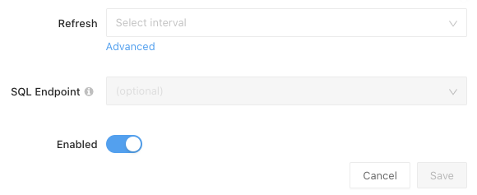
- In the Refresh every drop-down, select a period.
- In the SQL Warehouse drop-down, optionally select a SQL warehouse to use for all the queries. If you don’t select a warehouse, the queries execute on the last used SQL warehouse.
- Next to Subscribers, optionally enter a list of email addresses to notify when the dashboard is automatically updated.
Each email address you enter must be associated with a Azure Databricks account or configured as an alert destination.
- Click Save. The Schedule button label changes to Scheduled.
Domain
Production Pipelines
Question 39Skipped
The data engineering team is using a SQL query to review data completeness every day to monitor the ETL job, and query output is being used in multiple dashboards which of the following approaches can be used to set up a schedule and automate this process?
They can schedule the query to run every day from the Jobs UI.
Correct answer
They can schedule the query to refresh every day from the query’s page in Databricks SQL
They can schedule the query to run every 12 hours from the Jobs UI.
They can schedule the query to refresh every day from the SQL endpoint’s page in Databricks SQL.
They can schedule the query to refresh every 12 hours from the SQL endpoint’s page in Databricks SQL
Overall explanation
The answer is They can schedule the query to refresh every 12 hours from the SQL endpoint’s page in Databricks SQL,

The query pane view in Databricks SQL workspace provides the ability to add or edit and schedule individual queries to run.

You can use scheduled query executions to keep your dashboards updated or to enable routine alerts. By default, your queries do not have a schedule.
Note
If your query is used by an alert, the alert runs on its own refresh schedule and does not use the query schedule.
To set the schedule:
- Click the query info tab.
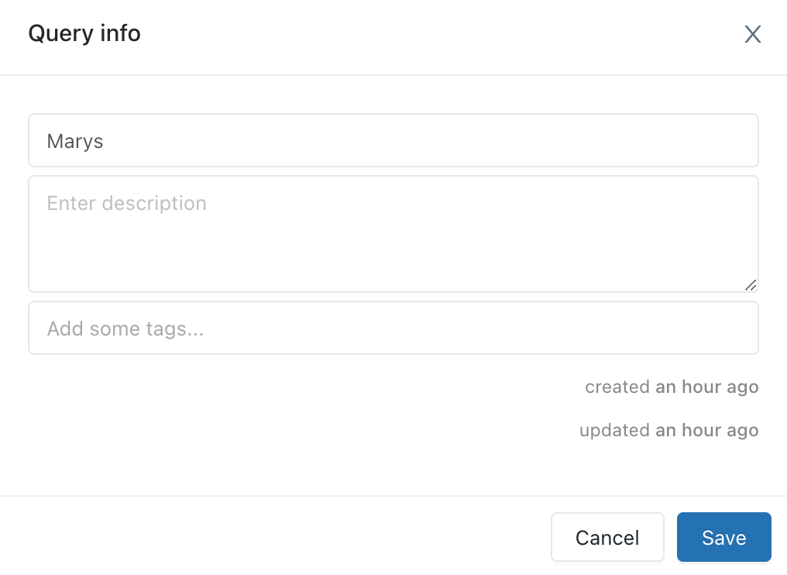
- Click the link to the right of Refresh Schedule to open a picker with schedule intervals.
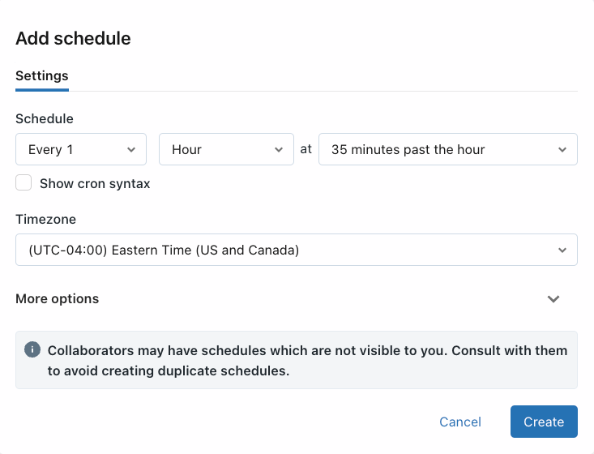
- Set the schedule.
The picker scrolls and allows you to choose:
  - An interval: 1-30 minutes, 1-12 hours, 1 or 30 days, 1 or 2 weeks
  - A time. The time selector displays in the picker only when the interval is greater than 1 day and the day selection is greater than 1 week. When you schedule a specific time, Databricks SQL takes input in your computer’s timezone and converts it to UTC. If you want a query to run at a certain time in UTC, you must adjust the picker by your local offset. For example, if you want a query to execute at 00:00 UTC each day, but your current timezone is PDT (UTC-7), you should select 17:00 in the picker:
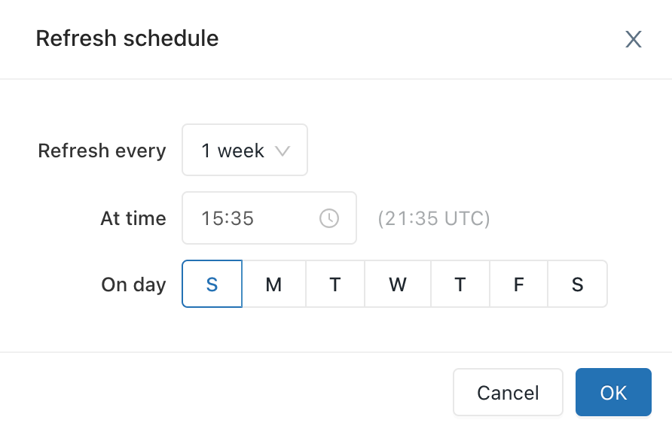

Domain
Production Pipelines
Question 40Skipped
A data engineer is using a Databricks SQL query to monitor the performance of an ELT job. The ELT job is triggered by a specific number of input records being ready to process. The Databricks SQL query returns the number of minutes since the job’s most recent runtime. Which of the following approaches can enable the data engineering team to be notified if the ELT job has not been run in an hour?
They can set up an Alert for the accompanying dashboard to notify them if the returned value is greater than 60.
They can set up an Alert for the query to notify when the ELT job fails.
They can set up an Alert for the accompanying dashboard to notify when it has not refreshed in 60 minutes.
Correct answer
They can set up an Alert for the query to notify them if the returned value is greater than 60.
This type of alert is not possible in Databricks
Overall explanation
The answer is, They can set up an Alert for the query to notify them if the returned value is greater than 60.

The important thing to note here is that alert can only be setup on query not on the dashboard, query can return a value, which is used if alert can be triggered.

Domain
Production Pipelines
Question 41Skipped
Which of the following is true, when building a Databricks SQL dashboard?
A dashboard can only use results from one query
Only one visualization can be developed with one query result
A dashboard can only connect to one schema/Database
Correct answer
More than one visualization can be developed using a single query result
A dashboard can only have one refresh schedule
Overall explanation
the answer is, More than one visualization can be developed using a single query result.

In the query editor pane + Add visualization tab can be used for many visualizations for a single query result.

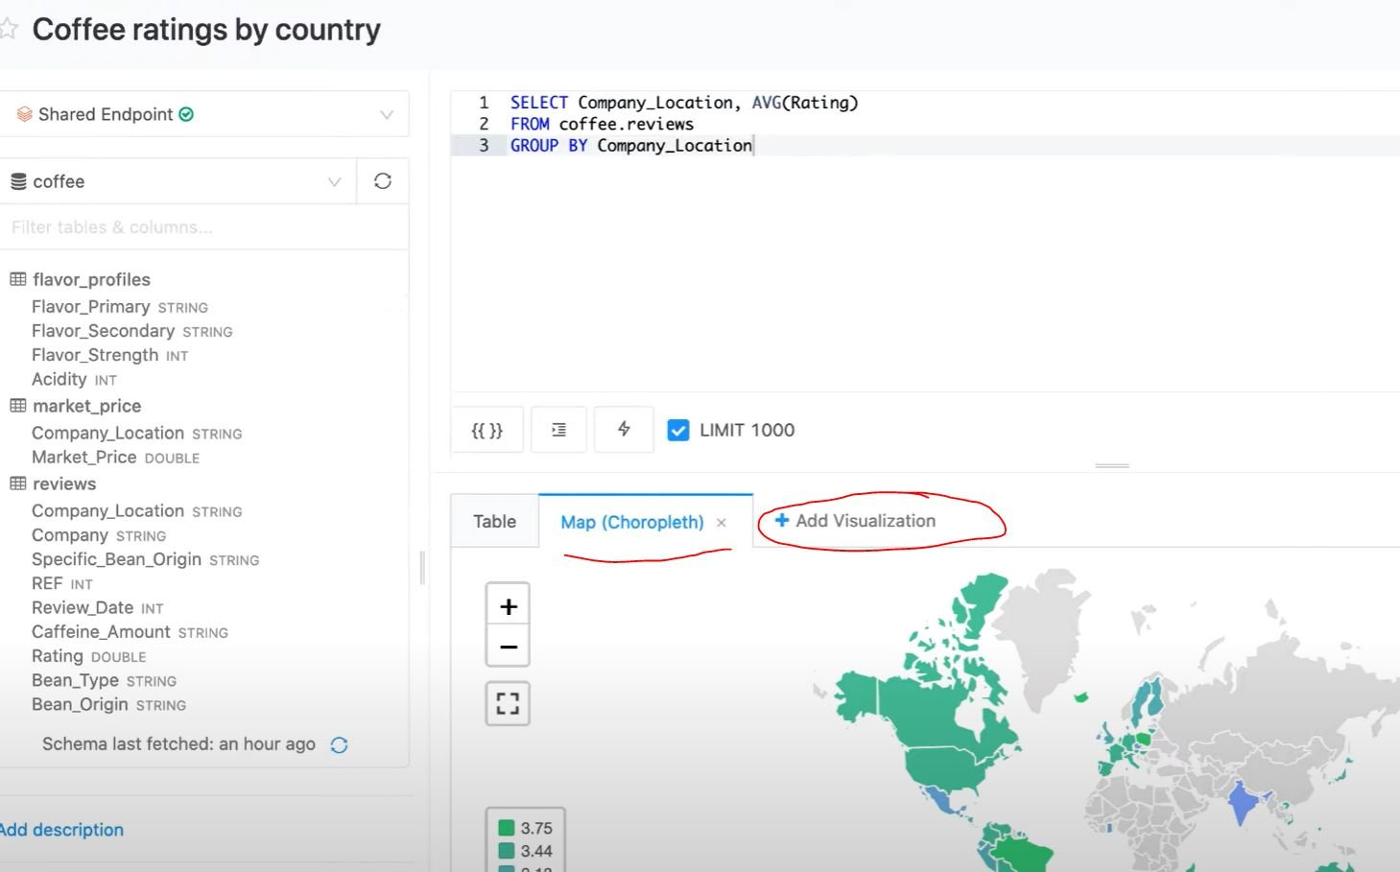

Domain
Production Pipelines
Question 42Skipped
A newly joined team member John Smith in the Marketing team currently has access read access to sales tables but does not have access to update the table, which of the following commands help you accomplish this?
GRANT UPDATE ON TABLE table_name TO john.smith@marketing.com
GRANT USAGE ON TABLE table_name TO john.smith@marketing.com
Correct answer
GRANT MODIFY ON TABLE table_name TO john.smith@marketing.com
GRANT UPDATE TO TABLE table_name ON john.smith@marketing.com
GRANT MODIFY TO TABLE table_name ON john.smith@marketing.com
Overall explanation
The answer is GRANT MODIFY ON TABLE table_name TO john.smith@marketing.com
https://docs.microsoft.com/en-us/azure/databricks/security/access-control/table-acls/object-privileges#privileges
Domain
Data Governance
Question 43Skipped
A new user who currently does not have access to the catalog or schema is requesting access to the customer table in sales schema, but the customer table contains sensitive information, so you have decided to create view on the table excluding columns that are sensitive and granted access to the view GRANT SELECT ON view_name to user@company.com but when the user tries to query the view, gets the error view does not exist. What is the issue preventing user to access the view and how to fix it?
User requires SELECT on the underlying table
User requires to be put in a special group that has access to PII data
User has to be the owner of the view
Correct answer
User requires USAGE privilege on Sales schema
User needs ADMIN privilege on the view
Overall explanation
The answer is User requires USAGE privilege on Sales schema,

Data object privileges - Azure Databricks | Microsoft Docs

GRANT USAGE ON SCHEMA sales TO user@company.com;

- USAGE: does not give any abilities, but is an additional requirement to perform any action on a schema object.

Domain
Data Governance
Question 44Skipped
How do you access or use tables in the unity catalog?
schema_name.table_name
schema_name.catalog_name.table_name
catalog_name.table_name
catalog_name.database_name.schema_name.table_name
Correct answer
catalog_name.schema_name.table_name
Overall explanation
The answer is catalog_name.schema_name.table_name

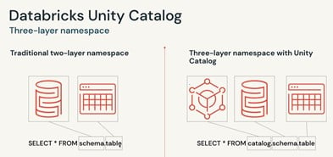

note: Database and Schema are analogous they are interchangeably used in the Unity catalog.

FYI, A catalog is registered under a metastore, by default every workspace has a default metastore called hive_metastore, with a unity catalog you have the ability to create meatstores and share that across multiple workspaces.

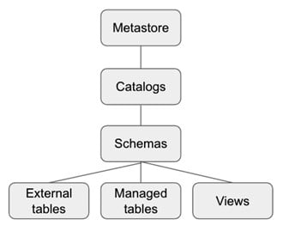

Domain
Data Governance
Question 45Skipped
How do you upgrade an existing workspace managed table to a unity catalog table?
ALTER TABLE table_name SET UNITY_CATALOG = TRUE
Correct answer
Create table catalog_name.schema_name.table_name
as select * from hive_metastore.old_schema.old_table
Create table table_name as select * from hive_metastore.old_schema.old_table
Create table table_name format = UNITY as select * from old_table_name
Create or replace table_name format = UNITY using deep clone old_table_name
Overall explanation
The answer is Create table catalog_name.schema_name.table_name as select * from hive_metastore.old_schema.old_table

Basically, we are moving the data from an internal hive metastore to a metastore and catalog that is registered in the Unity catalog.
note: if it is a managed table the data is copied to a different storage account, for a large tables this can take a lot of time. For an external table the process is different.
Managed table: Upgrade a managed to Unity Catalog
External table: Upgrade an external table to Unity Catalog

Domain
Data Governance

